**PROJECT REPORT TEMPLATE**

**1.INTRODUCTION:**

The report gives the India’s agricultural cultivation , providing a comprehensive visual exploration of key aspects and trends in the agricultural sector . Through this visual representation, gain valuable insights into crop production, seasonal variations, regional distribution and overall production trends . In this project , we have to put the data in the form of visualization , dashboard and story.

* 1. **OVERVIEW :**

Data analytics with tableau software can be used in this project. Tableau is an end - to - end data analysis platform that allows to prepare , analyze , collaborate and share the big data insights . In this project,the data set can be downloaded and put the dataset to the tableau desktop. The data set can be dragged . The visual representation of the graph can be split in minimum of five sheets can be shown. The five sheet can be displayed in dashboard. In each sheet,the story can be written. The visual representation of the graph and story telling can be uploaded in tableau public .

* 1. **PURPOSE:**

The purpose of this project users to create different charts, graphs, dashboard and stories for visualizing data to help in making buisness decisions. Through this visual representation of the graph , how much crops can be yield in a year and how much production in every district and it’s state.

**2. PROBLEM DEFINITION AND DESIGN THINKING :**

**2.1. EMPHATHY MAP**

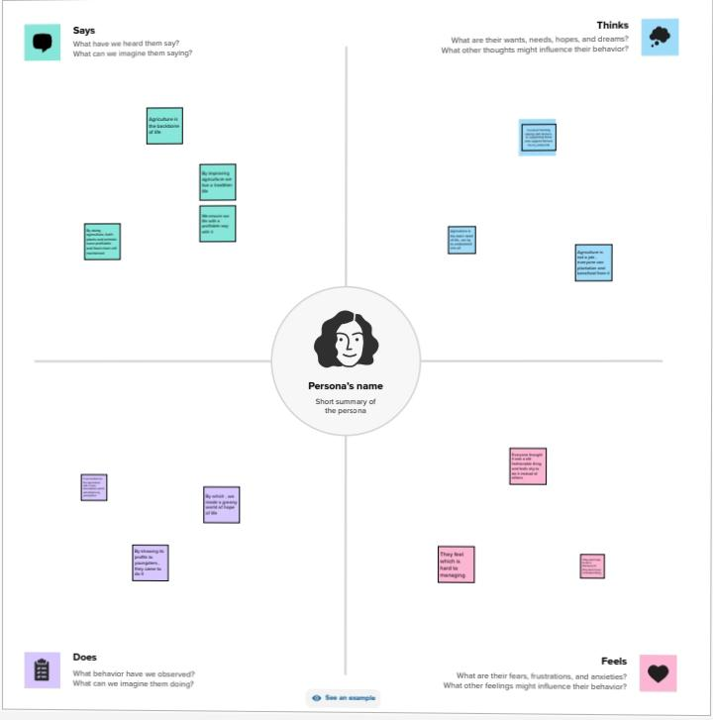

**2.2. IDEATION AND BRAINSTORMING MAP**

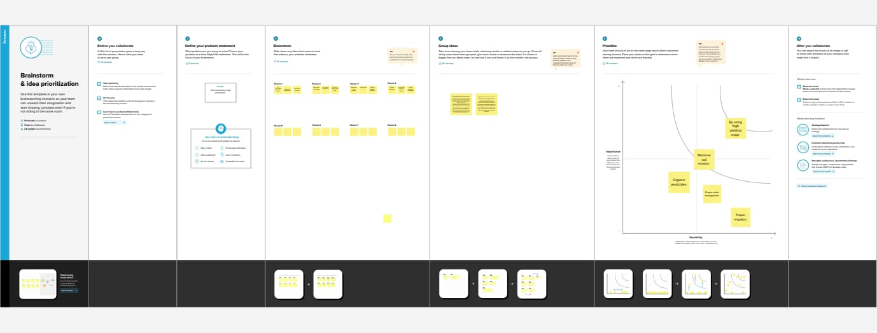

**3.RESULT:**

The India’s agricultural crop production can be simply shown in the visual representation and it can be easily understood. The graph can be dragged in tableau desktop. The dashboard and story can be uploaded in tableau public.

**4.ADVANTAGES & DISADVANTAGES:**

**ADVANTAGES:**

* Large amount of data can be used to generate a variety of visualisation without compromising the dashboard performance.
* It is a leading data visualisation tool used for data analysis and buisness intelligence.
* Easy to upgrade.

**DISADVANTAGES :**

* The drawbacks such as requiring more time , effort, skills to design ,develop and maintain the static charts and potentially increasing the complexity.
* No automatic refreshing of reports.
* Require SQL knowledge.

**5.APPLICATION:**

Tableau has a lot of unique features that it make if one of the most popular tools in buisness intelligence. Data analytics can be applied in buisness in various ways . It can be used to analyze customer behaviour, optimize , marketing campaigns, improve supply chain management, enhance product development, predict demand , identity fraud , optimize pricing strategies etc.

**6.CONCLUSION:**

Tableau is an effective data analytics tool because of its ability to connect to a wide range of data sources , its intuitive drag-and-drop interface , its flexible visualisation options , its ability to handle large data sets , its advanced analytics features and its strong community support.

**7.FUTURE SCOPE:**

Data analytics and data analytics boot camp is a huge industry and is predicted to keep growing. Companies have experienced a significant impact because of the data analytics industry, especially in their day-to-day buisness. It is to make better products and delivers higher- quality services.